Class imbalance arises from the fact that detectors need to evaluate a huge number of candidate regions, but only a few contain objects of interest. In other words, class balance is severely skewed toward negative examples (e.g., background regions), most of which are easy negatives. The presence of large amounts of easy negatives can overwhelm the training process, leading to bad detection results. Two-stage detectors can handle this class imbalance issue much better than one-stage detectors, because most negative proposals are filtered out at the region proposal stage.

Negative examples 이란? 학습에 불필요한 정보라고 봐야겠다.

* 2단계 필터링이 효과가 좋을 것이다.

여기선 negative sample에 대해서 필터링을 진행한다는 건가?

* 여기선 negative example이 무수히 많은 사례여서 이를 제거하는 데 사용한다는 거구나.
* This class imbalance issue 는 region 등의 negative example에 대한 imbalance 해소
* 좀 더 구체적으로 볼 필요가 있겠네.
* 2단계 검출기에 대한 연구가 있었는 듯! 좀 더 파봅시다!
* CenterNet: Keypoint Triplets for Object Detection [1단계 검출기]
  + Detection 딴에서는 이미 연구가 되고 있었던 분야인가 보다.

distribution mismatch is a common problem when semi-supervised methods are applied for medical image analysis. Exiting studies suggest this will cause the performance of semi-supervised methods to degrade drastically, sometimes even worse than that of a simple supervised baseline ([Oliver et al., 2018](https://www.sciencedirect.com/science/article/pii/S1361841522000913" \l "bib0294); [Guo et al., 2020](https://www.sciencedirect.com/science/article/pii/S1361841522000913" \l "bib0295)). Therefore, it is necessary to adapt semi-supervised algorithms to be tolerant of the distribution mismatch between labeled and unlabeled medical data. As a related field, “domain adaption” may provide insights for achieving this goal.

* Distribution mismatch로 인한 성능 감소 연구 있음
* 이건 semi-supervised method 에 한정되는 것 같은데, supervised learning 의 경우도 해당되려나?

**Deep Learning for Two-Step Classification of Malignant Pigmented Skin Lesions**

Kaymak, S., Esmaili, P., & Serener, A. (2018, November). Deep learning for two-step classification of malignant pigmented skin lesions. In *2018 14th Symposium on Neural Networks and Applications (NEUREL)* (pp. 1-6). IEEE.

In this paper, an automatic detection of malignant pigmented skin lesions is investigated. For this, the two-step skin lesion diagnostic procedure of the dermatologists is followed.

피부암 진단에 대해서 전문의의 진단과정에 맞춰서 2단계 피부병변 진단 절차를 진행한다.

* 성능이 좋지 않다.

2단계 연구 : Patch + WSI 이것도 의미하나 보네

중의적으로 사용된다.

# A Novel Two-Stage Deep Learning Model for Efficient Network Intrusion Detection

# Khan, F. A., Gumaei, A., Derhab, A., & Hussain, A. (2019). A novel two-stage deep learning model for efficient network intrusion detection. *IEEE Access*, *7*, 30373-30385.

Using two-stage deep feature learning, it has been shown that the proposed model is able to detect old and new intrusion attacks and is less influenced by the presence of an unbalanced class distribution problem between normal and abnormal traffic on one hand, and between the different categories of attacks on the other.

Standard MLP 보다 성능이 뛰어나다.

two-stage deep learning (TSDL) model 모델의 구조란?

based on a stacked auto-encoder with a soft-max classifier, for efficient network intrusion detection.

* 2 step 에 대한 성능이 올라갔다는 연구 결과가 있다.

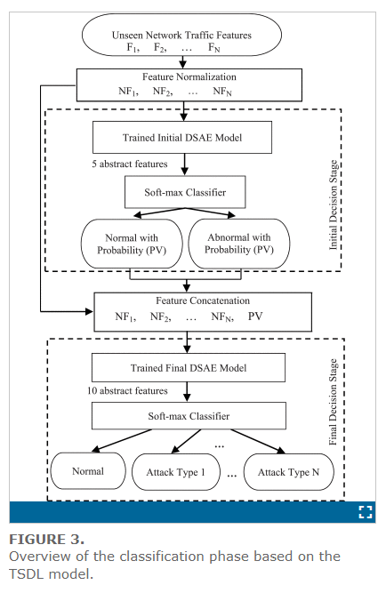

The KDD99 dataset is widely used for NIDS performance evaluation [52].  This dataset produces unbalanced distribution among the different classes of the traffic

